1. **Write a Python script to list all the prime numbers from 1 to 100 using Sieve of Eratosthenes.**

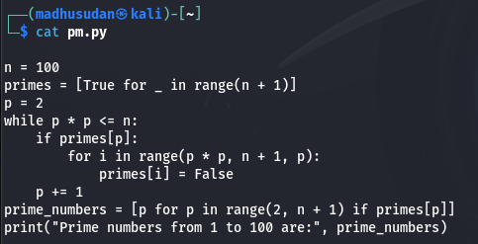

**Output**

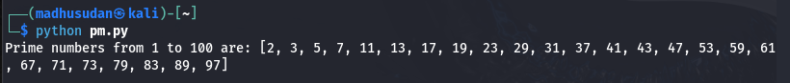

**2. Write a Python script to implement RSA algorithm using build in functions (both encryption and decryption)**

1. **Write a Python script to implement RSA algorithm with out using build in functions (both encryption and decryption)**

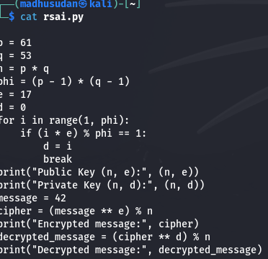

**Output**

